**Start** by selecting a line in the top middle. (Green vs Red)

* From there a map should appear in the UI.
* Select a block via drop down or by clicking on the block directly.
* Information about the track should show up on the right.(Including Block Occupancy)
  + If the user wants to upload a different track layout, they can do so by clicking the green upload track layout button and selecting an XML or CSV file.
* Murphy can select a failure by selecting a block and click the button to trigger that failure.
* The Track Model can toggle the track heaters by changing the environmental temperature.

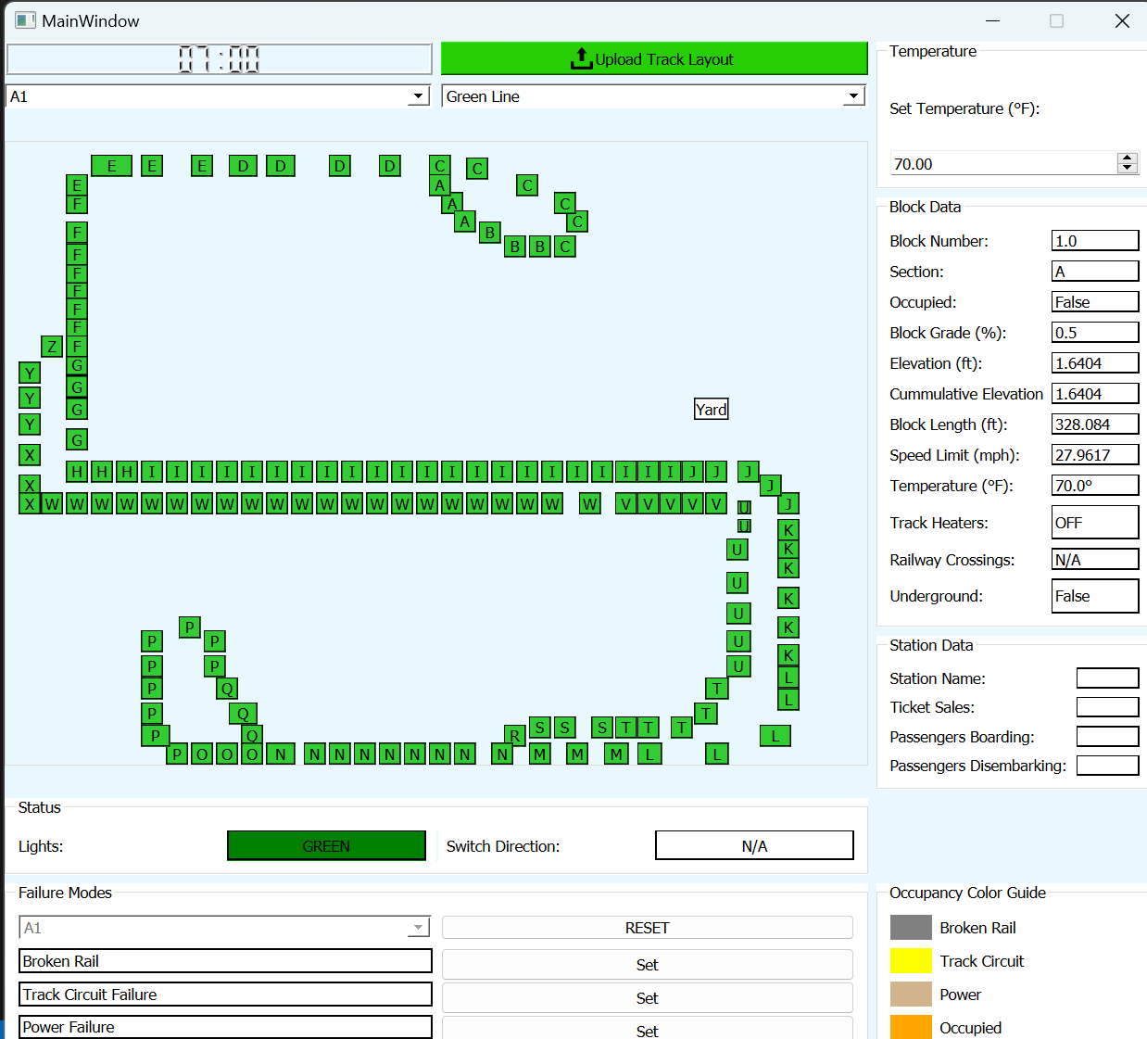

FAQs

* Why isn’t my map showing up?
  + Select a line.
* How can I tell where the train is?
  + Block occupancy is shown on the map.
* How can Murphy cause a failure?
  + At the bottom, Murphy can click one or all of the buttons to cause a specific failure to the track.
* Can I run multiple trains on the same line?
  + YES
* How can I tell what the light/switch/crossing status is?
  + The light and switch status are shown under the map, the crossing status is shown on the right towards the bottom.